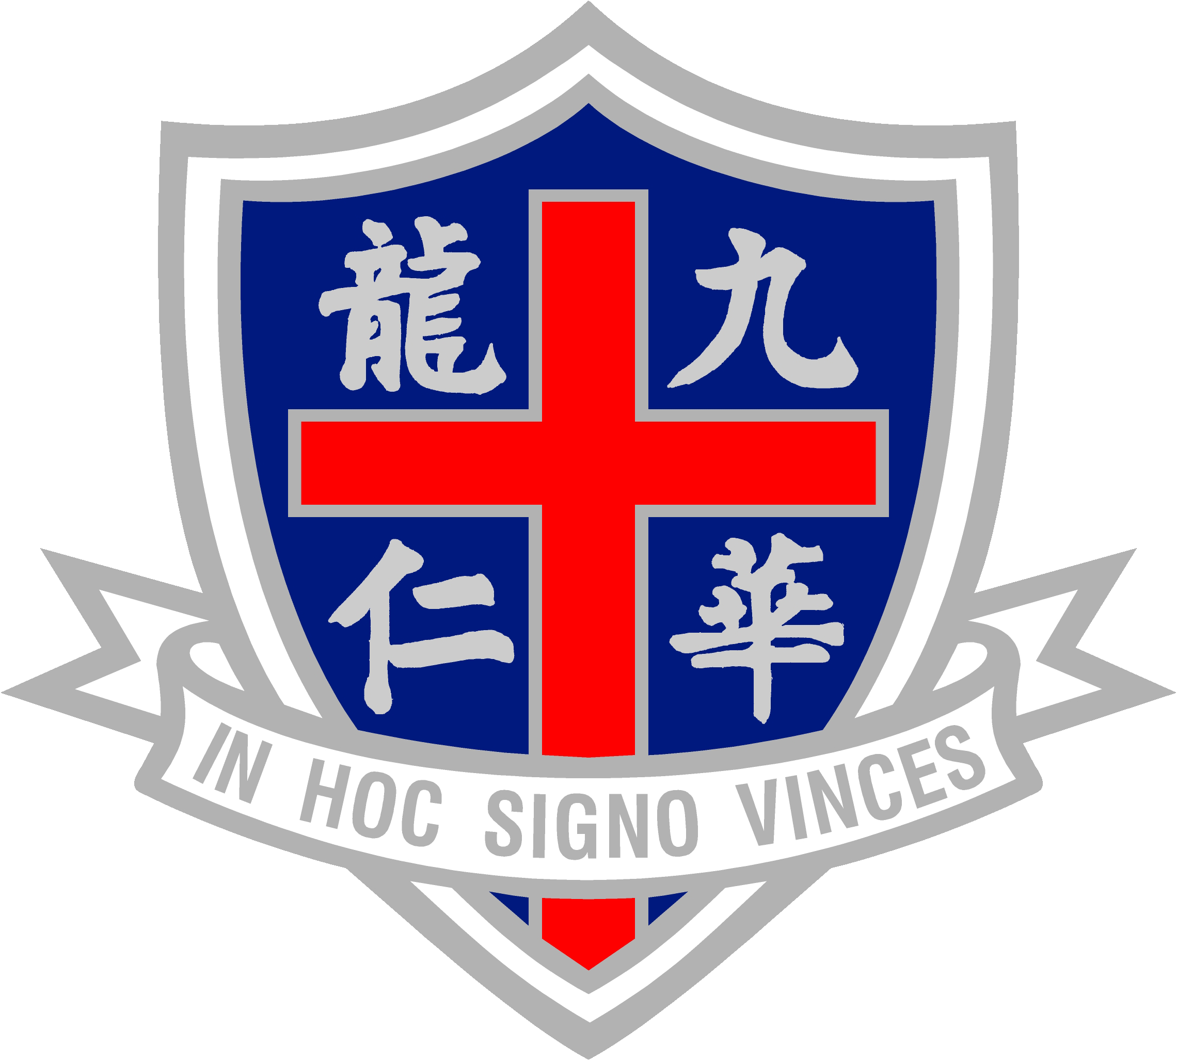 | Rev. Father Patrick J. Finneran Memorial Fund  Of your charity pray for the repose of the soul of Fr. Patrick J. Finneran, S.J.  Official web site: http://cs7076.comp.hkbu.edu.hk/~finneran
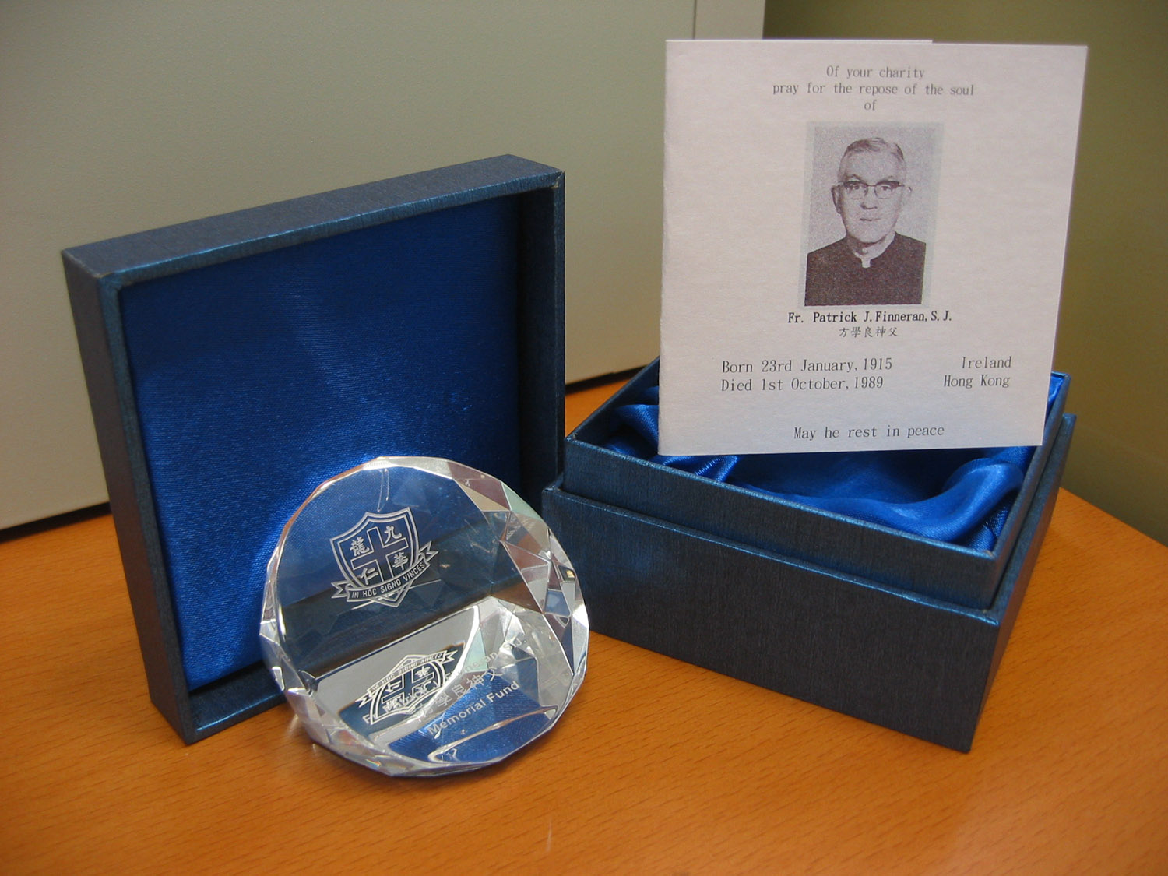  Fund Raising Souvenir: Crystal Paper Weight at HK$ 800.00  Please contact one of the office bearers listed below for ordering it. |  | 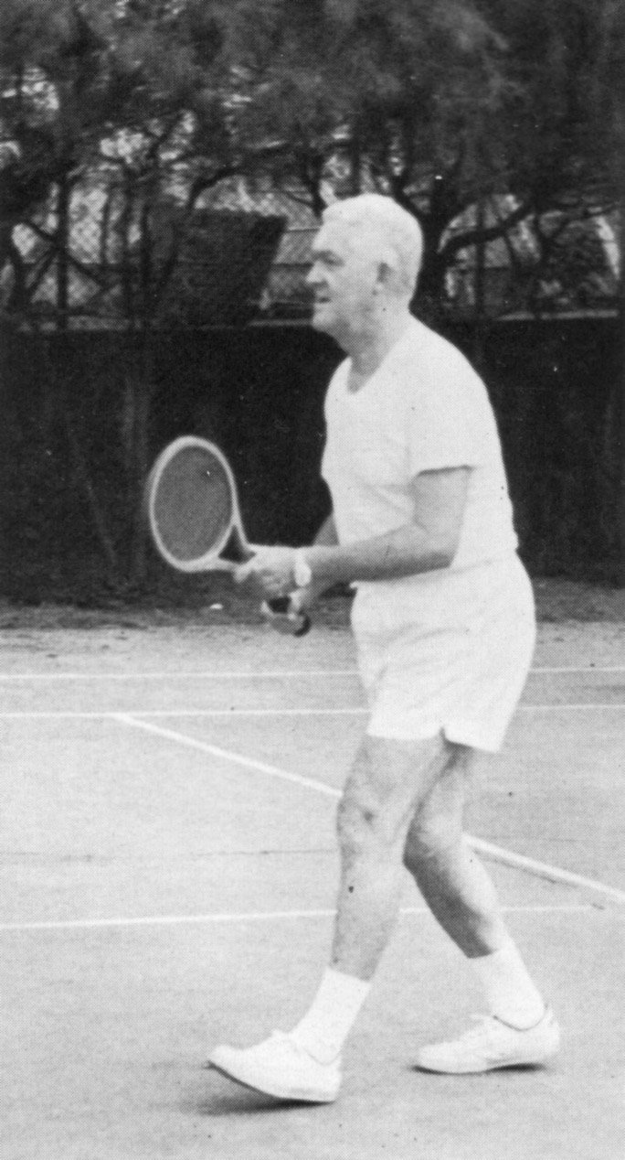  Born 23rd January, 1915 Ireland  Died 1st October, 1989 Hong Kong

Rev. Father Patrick J. Finneran Memorial Fund

Background
This Memorial Fund was set up as a tribute to Rev Father Patrick J Finneran, S.J. who had devoted his life to nurturing generations of Wah Yan College Kowloon students in their formative years. Father Patrick J Finneran was born on 23 January 1915 in Roscommon in Ireland and died on 1 October 1989 in Hong Kong. Fr. Finneran served the Wah Yan College Kowloon community with pride and dignity for over three decades before God took him away from us to a better place. He was buried at the St. Michael’s Catholic Cemetery in Happy Valley, Hong Kong.

Why did we launch the fund nearly 17 years after Fr Finneran passed away?

The late Mr. Francis Kong was sponsoring sporting activities and looking after the Tennis Team after Fr Finneran's death. Mr. Kong was a staunch supporter of extra-curricular activities in WYK before his tragic death last year. Many of us benefited from Mr. Kong’s generosity of treating us to a lunch buffet when we performed well in interschool sports competitions.

Now that Mr. Kong passed away, it was felt appropriate to set up a designated fund as a living memorial for Fr. Finneran, taking inspiration from his sporting contributions in WYK. In the summer of 2006, Mr. William Lee (1972 WYK Tennis Team Captain) organized a group of WYK ex-students - Wahyanites to set up a memorial fund to commemorate and support in perpetuity the kind of commitment Fr Finneran had shown for WYK students.

Objective
The main purpose of the fund aims to support the ongoing sporting activities pursued by the present generation of WYK students and honour those outstanding young sportsmen who pursued excellence.

About the Memorial Fund
This Memorial Fund will be operated by a group of Wahyanites serving as Members to the Executive Committee of the fund. We are looking for an expanding membership to make the Fund sustainable. All Wahyanites are welcomed to join by paying a membership fee which helps to operate the fund. For further details, please contact one of the office bearers below.

The office-bearers and members of the Executive Committee are non-paid ex-WYK student volunteers. There will be an annual election of office bearers to ensure greater involvement and sustainability of the movement. The Executive Committee will meet with Wah Yan College Kowloon staff and students to find out their needs and areas of sporting interests every 3-6 months. Every year, funds will be raised by the Executive Committee to support the sporting activities in Wah Yan College, Kowloon. Full autonomy will be delegated to WYK staff and students on the use of allocated funds to meet their changing needs. The funds will help WYK students to buy new sports equipment, sponsor coaching activities and training camps and recognize those sportsmen who pursued excellence. The launch of the memorial fund will be held on 1 October 2006 to commemorate Fr. Finneran’s death anniversary.

Memories of Father Finneran
Fr Finneran joined the Society of Jesus in Ireland and was an excellent sportsman himself in tennis, football, golf and athletics. Fate played a big part for Fr. Finneran to join the teaching staff of Wah Yan College Kowloon in Hong Kong in the 1950s. Teaching with great enthusiasm on the subjects of English and Religious Knowledge, he was also well remembered for being a Class Teacher for Form 5B (or Form 5A2 in the 80s). He spent long hours teaching boys the Catholic faith and was instrumental in many Wah Yan Kowloon boys becoming Catholics. He also offered sound career guidance and advice to many of us who became established professionals, businessmen and teachers in later life.

After his golden years in competitive sports were over, Fr Finneran concentrated on bringing up younger generations of sportsmen, in particular tennis players. He was best remembered for coaching the school tennis team to 10 successive championships from 1972-1981, which was a record unlikely to be repeated for many years to come. This sporting achievement may neither be mentioned in the same breath as what Matt Busby and Alex Ferguson did for Manchester United in English football nor Roger Federer, Pete Sampras and Bjorn Borg’s runs of successes in Grand Slam singles tennis championships, but it was an amazing coaching record turning out 10 successive winning teams in any sports.

Fr. Finneran brought solidarity, team spirits and discipline to his sports teams. He was dedicated to the pursuit of excellence and his recipe for success was hard work, practice and consistency. What we failed to realize at the time was that Fr. Finneran already prepared us to handle both winning and losing situations in future life.

For many of us, Fr Finneran had been an outstanding priest, a respected teacher, a passionate coach, a lifelong mentor and a trusted friend in different stages of our life. The least that we could do for Fr Finneran was to start a living memorial to remind future generations of Wah Yan students what a great man he was.

Acknowledgement
The setting up of the fund would not have been possible without the generous support of Fr A. Deignan, Fr Baptista and Mr. Norman So.

Donation
If you are interested to order our Fund Raising Souvenir (Crystal Paper Weight at HK$800) or to make a donation, please contact:
- Joseph Ng (jng@comp.hkbu.edu.hk)
- Anthony Lee (anthony_m_lee@yahoo.com.hk)

